Overall View

Scroll left in the VI to see: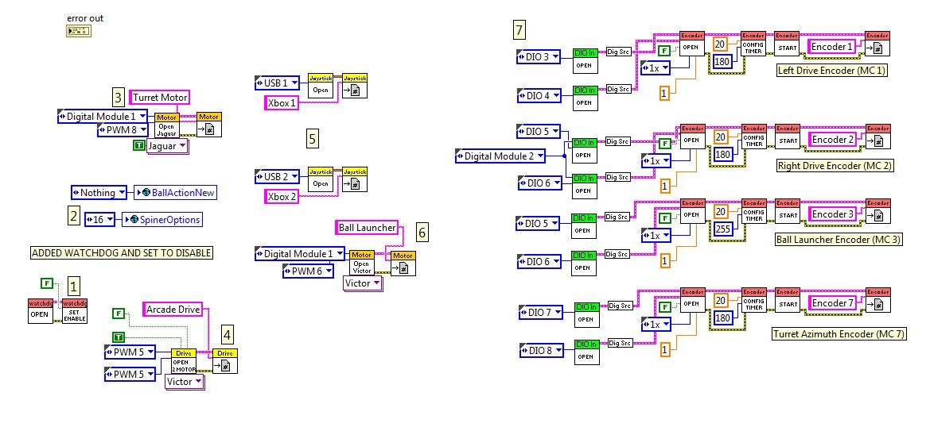

Scroll right in the VI to see: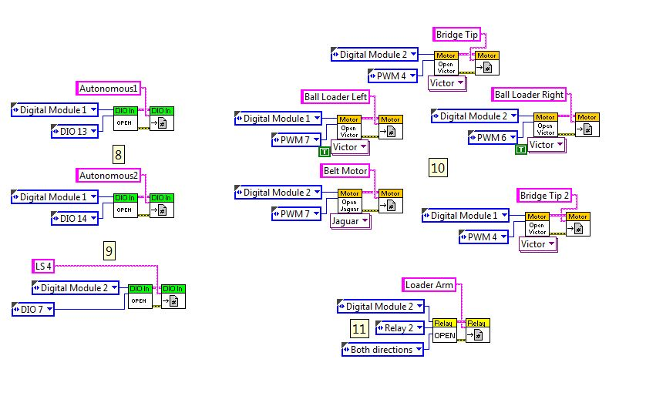

1. **Watchdog Set to Disable**: possible solution to runtime errors while running code on the robot.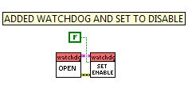
2. **Initialization of global variables (ones that have an earth icon near them):** allowed us to set default values for the variables (note: they are used later on in the code in order to determine robot behavior).

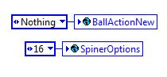

1. **Turret Motor Initialization:** opened jaguar type motor on PWM8 DIO1 and set a reference named “Turret Motor”.

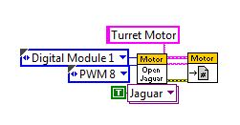

1. **Arcade Drive Initialization:** chose 2 motor drive type (will depend on the robot in the future), set both motors on PWM5 (different DIO boards), and inversed the motors according to testing to make correct direction movements.

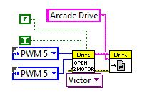

1. **Joystick Initialization:** created two joystick references named xbox1 and xbox2 connected to usb1 and usb2 respectively.

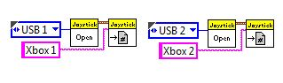

1. **Ball Launcher initialization:** opened a Victory type motor at pwm6 and created a reference to it.

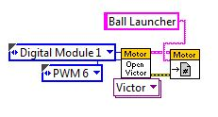

1. **Encoder Initialization:** opened four encoders (ignore the numbering) and created references to them.

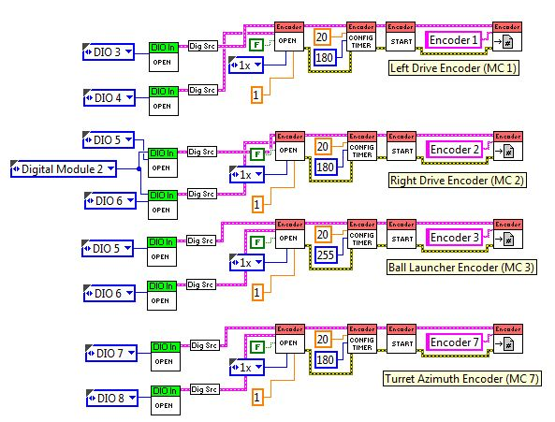

1. **Autonomous switch initialization:** opened 2 digital input/output channels named autonomous1 and autonomous2.

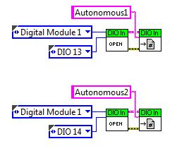

1. **Limit switch initialization:** opened a limit (digital input/output) and created a reference to be used in detecting the ball within the robot.

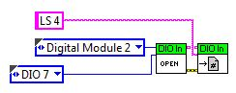

1. **Secondary motor initialization**: opened 5 secondary motors (see reference names for details) and created references for them.

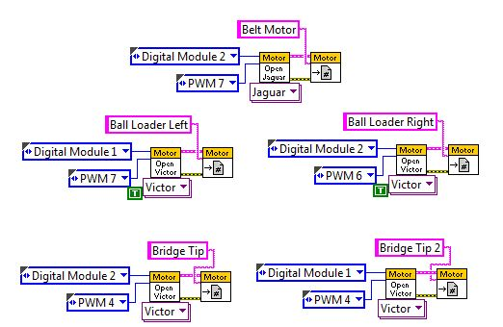

1. **Relay Initialization:** opened and referenced one relay used to control the loader arm.

